SOUTH WEST ORIENTEERING ASSOCIATION
SECRETARY: Helen Kelsey
Tel. 01278 723246. Email kelseys4@btinternet.com

MINUTES OF 2021 ANNUAL GENERAL MEETING
Held online using Zoom on Tuesday 5th October 2021 at 20.00

Those present:
Officers: Christine Vince KERNO, Chairman; Helen Kelsey BOK, Secretary; Steve Robertson QO, Treasurer and Membership Secretary; Richard Sansbury QO, Fixtures Secretary;.
Committee: Dick Keighley WIM, Pete Maliphant BOK, Arthur Vince KERNO, Julie Astin WSX
SW members: Carol Iddles BOK; Roger Hargreaves KERNO, Andy Reynolds DEVON; Jolyon Medlock WSX; Neil Fraser NWO; Kevin Pickering WIM; Paul Taunton NGOC .
Guests: Liz and AlanYeadon SARUM

The meeting opened at 8.05pm.

- Apologies
No Apologies received

2 Approval of Minutes of 2020 AGM
It was noted that Liz Yeadon should have been recorded as a guest not a SWOA member, with this amendment the minutes were approved as a true record of the meeting.

3 Matters arising from those minutes
The lack of a report regarding SWOA membership has been addressed, see Treasurer and Membership Secretary’s report.

4 Reports were issued in advance to all who attended.
4.1 Chairman’s report. Christine Vince. [Appendix1]

4.2 Fixtures Secretary’s report. Richard Sansbury. [Appendix 2]
It was noted that the SW JK for 2021 had been cancelled and queried whether SW would be asked to put on the JK soon using the planned areas, possibly in the event of another region being unable to stage the event. CV said that this would be considered. RH pointed out that having lost Hayle Towans (permanently) we have no suitable relay area.

4.3 SW Junior Squad Manager’s report. Pete Maliphant. [Appendix 3].
CV congratulated Pete and the rest of the team on keeping the Junior Squad going throughout lockdown and the excellent results at JIRC. PM conveyed his thanks to all the parents who supported the trip to Redcar for the JIRCs, as well as the enthusiastic juniors, whose ages ranged from 11 to 19 years.

4.4 Recorder of Controllers’ report. Arthur Vince. [Appendix 4]
AV commented that the imminent controller’s course run by BOK was very welcome and CV said that SWOA would be very happy to arrange further courses if the need was there. It is hoped that the October course will produce some new controllers for the region.

5 Treasurer and Membership Secretary’s report. Steve Robertson. [Appendix 5]

Membership numbers Appendix 5a
There was a reduction in membership numbers in 2020, no doubt due to COVID, the last 12 months have seen memberships much the same as the previous year, with 794 units representing 1180 individuals. BOK had offset the trend as membership numbers increased. The age profile highlights the issue of an aging membership, although encouragingly, there is a large number of 11-20 year olds. PM asked for an analysis of the junior members to identify where new juniors are coming from. This analysis is not currently available but can be provided later.
Finances
Finances over the last 5 years Appendix 5b
Details of finances in the last year Appendix 5c
The association achieved reasonable surplus in the last 12 months, despite the lack of events due to COVID. There have been quite a few events going ahead, resulting in a levy income of over £2000 and, during the period under consideration no grant applications were received, due to COVID restrictions on tours and overseas events, so cash reserves have gone up to nearly £11,000. SR reported that since the accounting period there have been 11 grants supporting juniors to a total of £2500 and more are expected. Banking arrangements are now fully active with a new account with Santander.

Approval of accounts for the financial year ending 31st July 2021:
The detailed accounts are with Mike Forrest who has agreed to complete an audit. Confirmation of the audit result will be reported in a subsequent committee meeting.

6 Membership fees for 2022
SWOA has not charged membership fees for some years, and it was agreed that the status quo should be maintained. The level of the SWOA levy was briefly discussed and it was agreed that this should go on the agenda for the next committee meeting.

7 Amendments to the Constitution
Amendment 1
Section 2 (b) (i). Remove the words "(who shall not serve as such for more than three years consecutively)"
There was some discussion about this and QO reported that they had changed their constitution from 3years to 5 years, rather than removing the term completely. It was noted that in the event that an a chairman had been in post for too long and was not embracing fresh ideas, the post could always be challenged at an AGM, regardless of length of tenure.
Passed by a majority.
Amendment 2
Section 2(b)
Insert new paragraph (iii): Elected officers and committee members must be individual members of SWOA and BOF.
Agreed unanimously.
Amendment 3
Section 2(b)
Change existing paragraph (iii) to read:
In addition there may be one representative from each affiliated specialist Orienteering Club; The representative must be a BOF member and the club must be affiliated to BOF.

Agreed unanimously.

Amendment 4
Section 6b to be replaced with:
Signatories to the SWOA bank accounts are Chairman, Secretary and Treasurer – their authority with the bank allows them to act independently.
SWOA internal governance allows payments of up to £300 to be made by one permitted signatory, payments between £300 - £600 require approval of a second signatory and any amounts above £600 shall be referred to the Executive Committee.

This amendment was required due to the terms and conditions of the new SWOA bank account.

Agreed unanimously.

8 Election of officers
8.1 Chairman: Christine Vince KERNO. Proposed by Dick Keighley, seconded by Roger Hargreaves
8.2 Administrative Secretary: Helen Kelsey BOK Proposed by Julie Astin, seconded by Arthur Vince.
8.3 Treasurer and Membership secretary: Steve Robertson QO. Proposed by Roger Hargreaves, seconded by Arthur Vince
8.5 Fixtures Secretary: Richard Sansbury QO. Proposed by Roger Hargreaves, seconded by Dick Keighley.

In the absence of other nominations, the above were elected.

9 Election of Committee
All of the following had previously said that they would be willing to serve on the committee: Dick Keighley WIM; Arthur Vince KERNO; Pete Maliphant BOK; Julie Astin WSX. All four were proposed by Andy Reynolds, seconded by Helen Kelsey. In the absence of other nominations, these four were elected. Two committee posts remain vacant; the constitution allows the Committee to co-opt members as necessary.
.

10 Any other business
There were no items of AOB.

The meeting closed at 8.50pm.

Minutes recorded by Helen Kelsey.

These minutes are issued subject to formal approval at the 2022 AGM.

Appendices:
1 Secretary’s report
2 Fixtures Secretary’s report
3 SW Junior Squad Manager’s report
4 Recorder of Controllers’ report
5 Treasurer and Membership Secretary’s report

Appendix 1
Chairman’s report

Chairman’s Report to SWOA AGM 2021

Thank you all for attending this year’s AGM. Since SWOA moved its business meetings on to Zoom, attendance has been very good. I will suggest to the Committee that this arrangement is made permanent.
First of all, I would like to congratulate Pete Maliphant and the SW Junior Squad on their excellent performance at the recent JIRCs. This is clearly due to the enormous amount of work that Pete put into keeping the Squad members interested via Zoom during lockdown.
Next I would like to thank those clubs who endeavoured to stage events but sadly were unable to, being obliged to cancel. Clubs are reporting continuing difficulties in obtaining land permissions, most notably from Forestry England.
Finally I would like to thank those clubs who were able to put on events; especially the clubs who organised the British Long Distance Championships on Braunton Burrows and the Caddihoe weekend in the New Forest.
Christine Vince, KERNO
SWOA Chairman

Appendix 2
Fixtures Secretary's Report

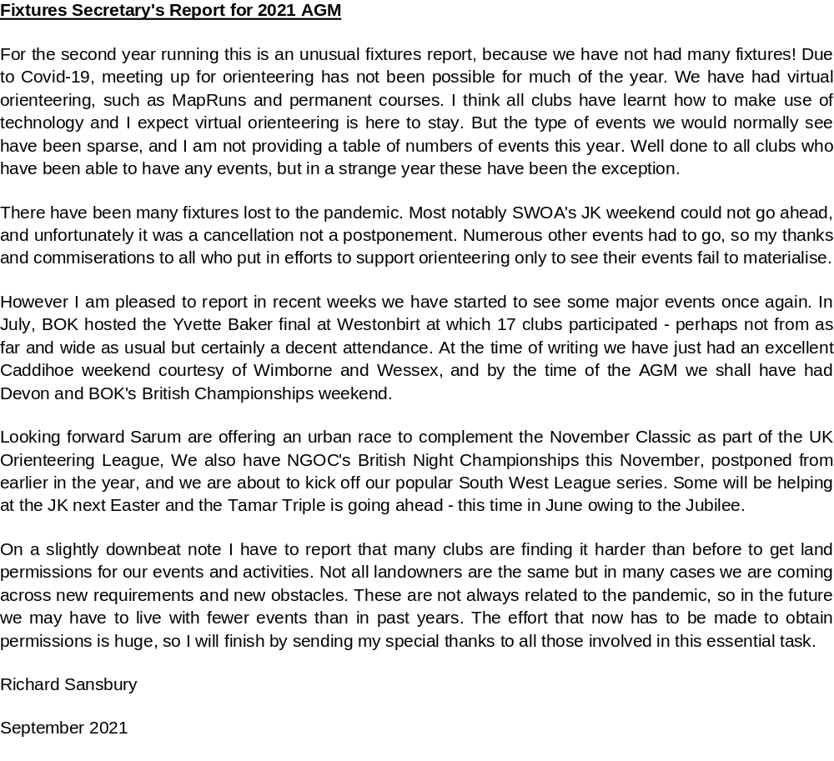
Appendix 3 SWJOS Report

SWJOS Review of 2020-21

The South-West Junior Squad provides a focus and a series of training activities for developing junior talent within the South-West. Athletes from BOK, Devon, NGOC, Wessex and Wimborne made up the 2020-21 squad. SWJOS has had another good year, despite covid, with 25 active and several more prospective members.

Squad Training
Normally training takes place during September-March aimed at achieving peak performances in the main Championships and selection races in March, April and May. This year has been about taking whatever opportunities arise, in whatever form, to train and compete.

We have continued our regular Zoom meetings since lockdowns began, less frequently once orienteering restarted, and should reach our 100th session early in 2022.

Training opportunities have been limited due to covid, the Forestry England situation, and now due to the very crowded race calendar. Having to pay £132 every time 10-20 juniors train for a day on FE land does not feel fair or reasonable, and we have raised this issue with Peter Hart.

Achievements
SWJOS has just returned from the annual Inter-Regional Champs in Redcar. I’m proud to report possibly the best SW performance in nearly 30 years. The South-West won both the Boys and Girls Relays, 2 of the 6 Individual races (Jim Bailey M18 and Lyra Medlock W14) and both the Individual and Relay runner up team trophies. To beat Scotland and the NW is a rare event indeed and the whole team, from the youngest to the most experienced, performed brilliantly. Parents, coaches and juniors thoroughly enjoyed the experience and the glorious late summer weather despite travelling a 600-mile round trip in 36 hours (during the fuel shortages)!

There were also 3 SWJOS winners and 2 podium places at the British Sprint and Middle Champs.

There have been numerous SW selections for summer camps and international races, not all of which have taken place in their usual format:

Lagganlia 14s: Lyra Medlock WSX, Grace French WIM, Harry Bratcher-Howard WIM
Ben Perry DEVON,
Badaguish 15s: Rose Taylor NGOC, Finlay Anderson BOK
Deeside 16s: Will Taylor DEVON, Emily Elms BOK
Stockholm 17s: Tom Perry DEVON, Lizzie Horsler WIM, Rebecca Ward NGOC
Gothenburg 18s: Olly Tonge BOK

GB team for Junior World Champs Jim Bailey
GB team for European Youth Champs Jim Bailey & Olly Tonge
England team for Junior Home Internationals Not yet public but we are represented

Will Taylor, Tom Perry, Lizzie Horsler, Rebecca Ward, Guy Owen and Jim Bailey are also part of the Talent South and National Talent squads.

However, SWJOS is not just about achievements at a national level and we welcome anyone who wants to travel widely, improve their skills and have fun as part of a close-knit team of orienteers.

Thanks are owed to all the parents who help and support SWJOS at each training day and to Jeff Butt, Dave Hanstock, Jim Hayward and Jamie Hayward for all their coaching work this season.

SWJOS provides development opportunities for junior athletes who are usually bottom year M/W14 or older, willing to and able to travel widely for their orienteering and keen to progress beyond Light Green courses, club and local races, to compete in major races nationally and progress towards the British Orienteering Talent Development Programme.

If you have anyone in your club who would like to find out more, please take a look at www.swjs.co.uk/about.html or contact any of the SWJOS families, Jeff Butt (Sarum) or me.

Peter Maliphant
BOK & SWJOS Coach

Appendix 4

SWOA AGM 2021
RECORDER OF CONTROLLERS’ REPORT

TRAINING COURSES
A Grade C training course is scheduled to be held in Bristol on 30th October, with Mark Dyer as the tutor.

RECORDER’S JOB DESCRIPTION
This can be found on the SWOA website in the SWOA Specific Documents section.

CONTROLLERS in the SW
SWOA clubs have 66 currently licensed controllers: 5 at Grade A, 20 at Grade B and 41 at Grade C. An up-to-date list of controllers is on the SWOA website in the Controllers section. The current list is dated 29th March 2021.
Ther have been no upgrades or new appointments since the 2020 AGM.

CHANGES to the list of controllers in SWOA

GRADE B Alan Simpson, formerly a member of DEVON, is now a member of a NEOA club and has been removed from the published list of controllers in the region.
James Head, formerly a member of NWO, is no longer a member of SWOA and has also been removed from the published list.

CLUB | Number of licenced controllers in club
 | Grade A | Grade B | Grade C | Total
BOK | 3 | 4** | 5* | 12
DEVON | None | 2 | 7 | 9
KERNO | 2 | 2 | 9 | 13
NGOC | None | 3 | 6 | 9
NWO | None | None | 1 | 1
QO | None | 2 | 4 | 6
SARUM | None | 1* | 2* | 3
WIM | None | 3 | 6*** | 9
WSX | None | 3 | 1 | 4
Total | 5 | 20 | 41 | 66

**Two licensed via WOA *One licensed via SCOA *** One licensed via SEOA

APPOINTMENT OF CONTROLLERS
Clubs and individuals are reminded that in order to become a licensed controller, or move from Grade C to Grade B, as well as completing the necessary training course and fulfilling the other BOF requirements it is necessary to be approved by their club and SWOA. Application forms are available from me. Grade A controllers are appointed by the BOF Events and Competitions Committee.

Arthur Vince, KERNO
28th September 2021

Appendix 5
Treasurer and Membership Secretary’s Report

5a
Membership numbers

5b
Finances over past 5 years
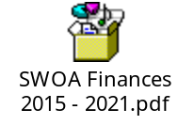
5c
Details of finances 2020-2021


