SOUTH WEST ORIENTEERING ASSOCIATION

SECRETARY: Helen Kelsey: 07816367460 / 01278 723246

[kelseys4@btinternet.com](mailto:kelseys4@btinternet.com)

MINUTES OF COMMITTEE MEETING Tuesday 21st January 2025

PRESENT:

Christine Vince KERNO (chairman); Helen Kelsey BOK (secretary); Steve Robertson QO (treasurer); Rob Mills WIM (fixtures); Pete Maliphant BOK (cttee and SWJOS); Arthur Vince KERNO (cttee); Julie Astin WSX (cttee); Neil Fraser NWO;(cttee); Kevin Pickering WIM (cttee);Liz Yeadon SARUM; Roger Hargreaves KERNO; Ian Jones NGOC; Ken Stimpson NWO; Richard Hudson BOK; Adrian Taylor DEVON.

1. Apologies. - none
2. Chairman’s update. – nothing to report
3. Approval of minutes of last meeting. – approved by the meeting
4. Matters arising not elsewhere on the agenda. - none
5. Treasurer and Membership Secretary’s report. – details in *appendix 1* no questions
6. Fixtures report.
   1. Update on progress with British Sprint and Sprint Relay Championships *see appendix 2*  all principal officials appointed except planner for day 1 at Bath University. Several possible candidates from BOK, but anyone suitable from other SWOA clubs very welcome to come forward for this.

Fixtures bulletin issued in November.

Issues from last meeting:

SN champs for 2025, we were struggling for an offer and DEVON and QO tried to work something out together, but we have now been informed that SE will be hosting in 2025. The SW will be hosting again in 2026 and WSX has expressed interest in using Studland Dunes.

CSC qualifier for 2026: WIM proposing to use an area not used for a long time, in conjunction with WSX, but parking is proving to be an issue. Any other offers welcomed.

British middle Championships 2027 (as EA have withdrawn their offer) – no offers as yet. It is usually held in the spring, but offers at other times would be considered. Liz suggested the possibility that the Sarum Saunter might be able to host it as the area is suitable for a large event – she will check with committee.

DEVON SWOL event at Harcombe (postponed due to storm Darragh) has been rearranged for 2nd March.

SOEUL league has has now been issued, SW events are:

Giilingham 8th March; Bridgwater 23rd March; Canford Heath 7th June; Tidworth 8th June.

Liz queried about SARUM event in April and post meeting it was noted that Warminster on 27th April is also a SEOUL event.

The event scheduling group meets in March, so any events in second half of 2026 wishing to be National events need to brought up at that meeting.

SWOA will be hosting the JK in 2028, so need to start looking for suitable venues.

Two papers from Forestry England confirming their pricing strategy were circulated, most people knew of the details but it is good to see it in writing and it should be distributed to all clubs. Julie confirmed that night events are considered to be Off peak and therefore charge is 15% of total income rather than 20%.

Small group training using only training kites has been agreed to incur no charge, which has made a big difference to SWJOS training sessions. Liz requested that any training sessions happening are notified through the fixtures secretary of the club whose area is being used.

Southern Championships and Junior selection races are being held at the SARUM Saunter on 9th March, will all clubs please advertise.

1. Appeal from NWO on decision to exclude Michinhampton event from SWOL

At very short notice, it had come to SWOA committee notice that the SWOL at Michinhampton could not allow under 16s to compete on Short Green, Green, Blue or Brown, due to road crossings. As 15 year olds usual course is either Green or Blue, this excluded most juniors from doing the course that they were competing in the league for. As this was against the spirit of fair competition the event was excluded from the league a few days before it happened. NWO, who put on this event have appealed against this decision, see *appendix 3*. There was much discussion about the restrictions on the event and the SWOA league rules. Whilst there was general agreement that this shouldn’t have happened at a SWOL event, the lack of specifically stating this rule in the SWOA rules and the large number of seniors who were disadvantaged by the removal of event from the league, there was considerable discussion about whether the appeal should be considered. The meeting voted against declining the appeal outright:10 against, 2 in favour, 3 abstensions.

The meeting then considered the appeal’s suggested Option 2 – to void courses Green and Blue and reinstate others for league scoring. 13 against, 0 for, 2 abstensions.

The final vote was to accept the appeal from NWO and have the results reinstated as part of the league. 13 for, 1 against, 1 abstension.

So the appeal from NWO was accepted and the results will be included in the SWOL.

It was generally agreed that SWOA now needs to take action to make certain that this unfortunate situation does not happen again as it clearly disadvantages our junior orienteers.

Pete pointed out that Green and Blue are the usual courses for W/M 16s and many course planners are unaware of this.

Arthur has proposed an amendment to the rules which should be passed around all the clubs for comment before the next committee meeting.

1. SWJOS report. Two more training days to go with thanks to SARUM and BOK for the use of their areas .
2. Recorder of Controller’s Report – nothing to report
3. Volunteering- nothing to report
4. AOB - none
5. Club reps report to clubs.

* Explanation of what occurred re Michinhampton and why it was controversial, indicating the usual courses for M/W 16s and stating that they must be available at all SWOL events. Suggested wording of the rule amendment for comment.
* Anyone interested in planning the British Sprint Championships at Bath University in 2026 should make themselves known to BOK.
* Any offers for venues for JK in 2028.
* Reminder that Sarum Saunter on 9th March is also Southern Championships and a junior selection race.
* Attach the two Forestry England papers re pricing and BOF agreement in case any clubs haven’t seen it yet.

1. Date of next meeting.

Tuesday 25th March

Appendix 1a

SWOA Membership - January 2025

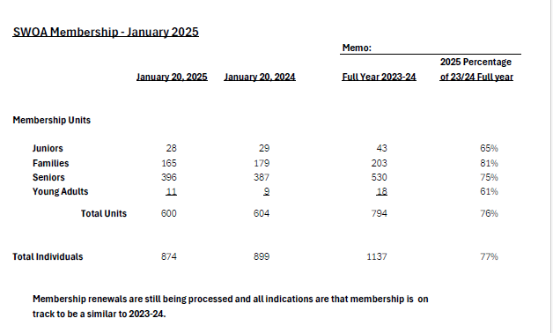

Appendix 1b

SWOA Financial Status -- January 2025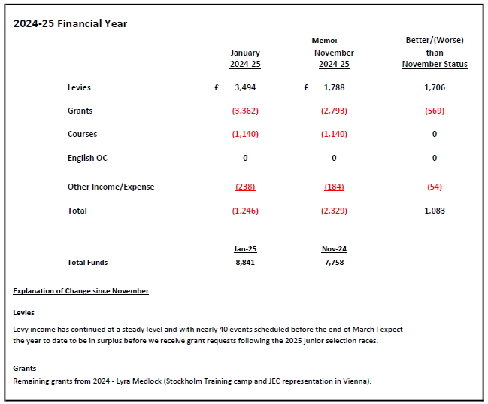

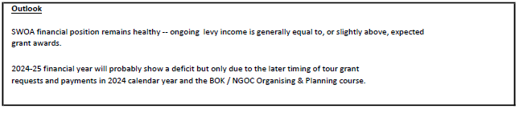

Appendix 1c

SWOA Summary by Account 2024-2025

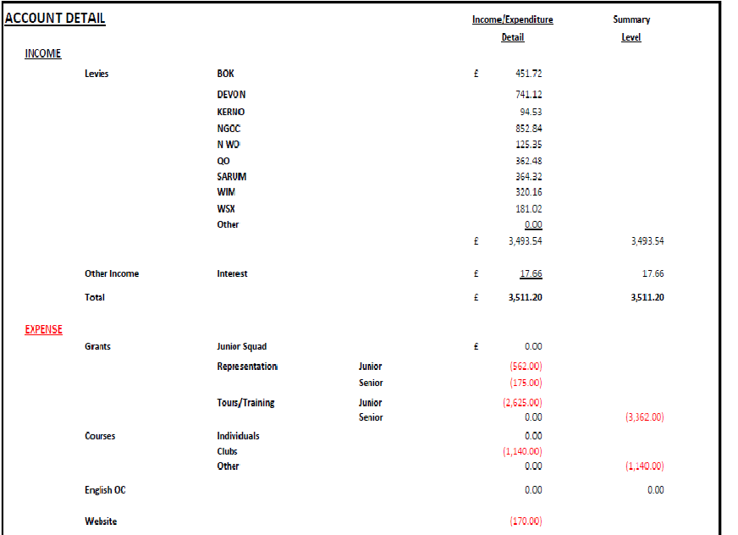

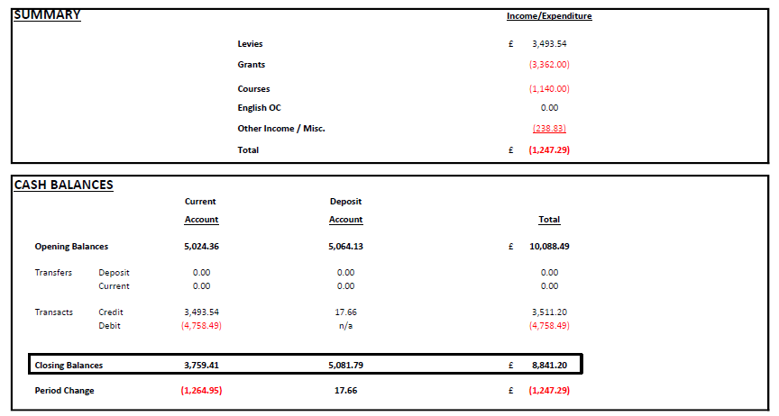

Appendix 2

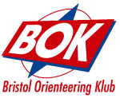

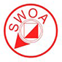

National Sprint Orienteering Championships Weekend 2026

Update Jan 2025 by R Hudson

Saturday 27 June 2026 – Individual Championships – Bath University

Sunday 28 June 2026 – Sprint Relay Championships – University of West of England

|  |  |  |
| --- | --- | --- |
| Item | Individual Champs | Relay Champs |
| Weekend Co-ordinator | Mike Forrest (BOK) | |
| Officials - Organiser | Richard Hudson (BOK) | Richard Rossington (BOK) |
| Officials - Planner | TBA | Richard Cronin (NGOC) |
| Officials - Controller | Simon Errington SEOA | Graham Nielson NWOA |
| Permissions | The date has been requested to the University and permission in principle has been given. But the details are to be finalised | The date has been requested to the University and permission in principle has been given. But the details are to be finalised |
| Embargoed Area | Posted on BOF website | Posted on BOF website |
| Mapping | Chris Johnson will update his current map as required in 2026. | Chris Johnson will update his current map as required in 2026. |

Appendix 3

**NORTH WILTSHIRE ORIENTEERS – APPEAL**

This is an appeal from North Wiltshire Orienteers for the reconsideration of the SWOA decision to remove SWOA League status from the Minchinhampton Regional Orienteering event on Sunday 19 January 2025.

The Minchinhampton event was planned, controlled and organised in accordance with British Orienteering Federation (BOF) guidelines. Due to the nature of the area, with numerous intersecting roads, personnel safety was accorded the highest priority, and BOF rules on road crossings for juniors were strictly implemented. When considering the resultant effect on course entry restrictions for juniors, event officials were unaware of any supplementary SWOA guidance regarding unrestricted entry for all. Consequently, unaccompanied juniors were barred from entry into the more technical courses.

We have now been advised that these restrictions contravene SWOA expectations and, as a result, SWOA have removed the event for league ranking.

From the first five events in this year’s league, it appears that a small number (3) of M/W14 juniors have completed either Green or Blue courses. One or two of these juniors may be candidates for “podium” positions on Blue or Green and the NWO entry restrictions for Minchinhampton will have removed for them a point scoring opportunity for this event.

NWO believe that it may be possible to implement some kind of mitigating action to minimise the effect of the entry restriction on the affected juniors without removing a points scoring opportunity from the other 140+ competitors, junior and senior, who have entered the event.

NWO forward the following for consideration:

* Option 1 - SWOA “provisionally” includes the event results in the league. After the final event in this year’s competition, the league organisers review the results to see if the Minchinhampton event has made any material difference to the overall results of the affected juniors. If so, organisers could then take appropriate action, otherwise the results would remain part of the league.
* Option 2 - An alternative would be to include the event in the league, void the results of the two affected courses (Green and Blue), while accepting all other course results. This would affect just over half of the event entrants.

These are by no means all the potential mitigants and you may be able to add your own ideas into any discussions. If required, NWO are happy to be involved in consideration of potential ways ahead.

NWO therefore request that SWOA reconsider the decision to remove the Minchinhampton event from the SWOA league. Some form of mitigating action could minimise the effect of course entry restrictions on the relevant juniors while still offering a points scoring opportunity to the vast majority of the event entrants.

We look forward to your considered response.

**Steve Jackson**

**Chairman North Wiltshire Orienteers**

**17 January 2025**